**Systemic and mucosal immune response of Nile tilapia broodstock to monovalent and bivalent vaccines against bacteria *Streptococcus agalactiae* and *Aeromonas veronii*.**

By

Quentin Ludovic Stéphane ANDRES

A Thesis Submitted in Partial Fulfillment of the Requirements for the Degree of

Master of Science in Aquaculture and Aquatic Resources Management

Examination Committee: Krishna R. Salin (Chairperson)

Ha Thanh Dong

Committee Member

Nationality: French

Previous Degree: Bachelor of Molecular Biology, Microbiology

and Genetics

University of Nice – Côte d’Azur

Nice, France

Scholarship Donor: None

Asian Institute of Technology

School of Environment, Resources and Development

Thailand

April 2022

**AUTHOR’S DECLARATION**

I, Quentin ANDRES, declare that the research work carried out for this thesis was in accordance with the regulations of the Asian Institute of Technology. The work presented in it are my own and has been generated by me as the result of my own original research, and if external sources were used, such sources have been cited. It is original and has not been submitted to any other institution to obtain another degree or qualification. This is a true copy of the thesis, including final revisions.

Date: TBC

Name (in printed letters): QUENTIN ANDRES

Signature:

**ACKNOWLEDGMENTS**

Type your acknowledgments here. This section is typically reserved for personal and professional dedications. You may also acknowledge your donor or funder here or include copyright acknowledgements of journals whose articles you have significantly incorporated in this thesis. Maintain one blank 1.5 line spacing between paragraphs.

[one page, maximum]

# ABSTRACT

Fighting bacterial infections inducing mass mortality in fish is a hot-topic research in the aquaculture field in order to be able to sustain its intensification. This research project aims to develop monovalent and bivalent vaccines against the bacteria *Streptococcus agalactiae* and *Aeromonas veronii* for prophylaxis of the fish Nile tilapia for which there is currently no existing vaccine available in Thailand. In the present research, vaccines were produced by pathogen inactivation method: formalin 1% ~ 3% (v/v) is added to the virulent pathogen solution. The objective of the study is to characterize a part of the immune response elicited in Tilapia in response to vaccination. A total of 400 to 600 Nile tilapia juveniles were stocked into experimental ponds/aquariums prior to the start of the experiments. The population was then split 4 in groups according to experimental design. After verification that the fish were free of any disease, they were acclimated for about a week. Meanwhile our 2 virulent pathogenic bacteria have been recovered and amplified on appropriate medium and were used for the vaccine production but also stored for challenge test. As a first step, a total of 4 treatments were administrated to the fish in order to monitor a possible immunization: 1 sham vaccine (a control vaccine with no immunizing properties) & 3 formalin inactivated vaccines containing either antigenic particles of *Streptococcus agalactiae* (monovalent); of *Aeromonas veronii* (monovalent); of *Streptococcus agalactiae* + *Aeromonas veronii* (bivalent with a 1:1 ratio). In a second step, the fish immune response to vaccination (=immunogenicity and survivability) was determined by titrating agglutinating antibodies but also with ELISA assay which is more reliable method. Indeed, isotype determination of antibodies (humoral/specific immune system) can allow to titer the concentrations of specific immunoglobulins M and immunoglobulins T for *Streptococcus agalactiae’s* polysaccharides and *Aeromonas veronii*. In addition, gene transcription activity from before, during, and after the immunization (up to 70 dpv) were determined by RT-PCR for IgM and IgT (active transcripts) corresponding to humoral immunity, and for SOD, CAT, GPx, NOS (respiratory burst activity of phagocytes) corresponding to innate immunity. As a final step, a challenge test *in vivo* was carried out on the fish juveniles with the two bacteria. Fish were injected with control (+PBS) or were injected a lethal dose of pathogen according to their prior vaccination.

**CONTENTS**

**Page**

ACKNOWLEDGMENTS iii

ABSTRACT iv

LIST OF TABLES viii

LIST OF FIGURES ix

LIST OF ABBREVIATIONS x

CHAPTER 1 INTRODUCTION 1

1.1 Background of the Study 1

1.2 Statement of the Problem 1

1.3 Conceptualization 1

1.4 Hypothesis 1

1.5 Objectives of the Study 2

1.6 Objectives of the Project 2

1.7 Risks and limitations 2

1.7.1 Project fundings 2

1.7.2 Access to laboratory facilities 2

1.7.3 Risks in experiments 2

1.8 Conceptualization 3

1.8.1 Project plan 3

1.8.2 Project schedule 4

1.8.3 Collaborating research teams 4

CHAPTER 2 RELEVANT LITERATURE 5

2.1 Relevant literature on *Streptococcus agalactiae* and *Aeromonas veronii* and their infections in Nile tilapia. 5

2.2 Relevant literature on formalin killed vaccines (FKVs) 5

2.3 Relevant literature on antibody agglutination titration, ELISA 5

2.4 Relevant literature on systemic and mucosal fish immunology 5

2.5 Chapter Summary 5

CHAPTER 3 METHODOLOGY AND RAW MATERIAL 6

3.1 Project steps overview 6

3.2 Experimental design and statistical power analysis. 6

3.3 Methodology for pond preparation and fish stocking 7

3.4 Methodology for bacterial culture and bacterial preparation 7

3.5 Methodology for preparation of formalin killed vaccines (FKVs) 7

3.6 Methodology for vaccine administration in fish and monitoring of fish health during bacterial challenge test. 7

3.7 Methodology for fish sera and mucus extraction. 7

3.8 Methodology for ELISA assays for specific IgM, IgT titrations 7

3.9 Methodology for RT-PCR 7

3.10 Methodology for antibody agglutination titration 7

3.11 Methodology for data curation and result analysis 7

3.12 List of raw material 7

3.13 Price of raw material 7

3.14 Chapter Summary 7

CHAPTER 4 EXPERIMENTS AND RESULTS 8

4.1 Experiment #1 8

4.2 Experiment #2 8

4.3 Chapter Summary 8

CHAPTER 5 CONCLUSION 9

REFERENCES 10

APPENDICES 11

APPENDIX A TITLE 12

APPENDIX B TITLE 13

VITA 14

Education 14

Conferences & Workshops 14

Trainings & Self-Learning MOOCs 15

# LIST OF TABLES

**Tables Page**

# LIST OF FIGURES

Figure 1 *Project plan* 3

Figure 2 *High level schedule* 4

Figure 3 Antibiogram (general principle) 7

# LIST OF ABBREVIATIONS

|  |  |
| --- | --- |
| **Av**  **Sa**  **FKV** | = *Aeromonas veronii*  = *Streptococcus agalactiae*  = Formalin killed vaccines (Pathogens inactivated using formalin) |
| **GBS**  **GP**  **MIC**  **S.**  **% (v/v)** | = Group B streptococci  = Gram-positive  = Minimum inhibitory concentration  = Streptococcus  = Volume per volume (Volume concentration of a solution) |
| **TSR/TSB** | = Tryptic soy broth |
| **BHI** | = Brain heart infusion |
| **CFU** | = Colony-forming units (CFU) |
| **HKV** | = Heat killed vaccines |
| **TSA** | = Tryptic soy agar |
| **IgM** | = Immunoglobulins M |
| **IgT** | = Immunoglobulins T |
| **SBVN** | = Streptococcus agalactiae serotype SBVN |
| **ppt** | = Parts per trillion |
| **PBS** | = Phosphate buffer saline |
| **IFA** | = Incomplete Freund adjuvant |
| **ELISA** | = Enzyme-linked immunosorbent assay |
| **PBST** | = |
| **PBSTM** | = |
| **Tween20**  **Dpv**  **MLST**  **rMLST** | = Detergent 20% of Tween  = Day post vaccination  = Multilocus Sequence Typing  = ribosomal Multilocus Sequence Typing |
| **TMB** | = 3, 3′, 5, 5′-tetramethylbenzidine |
| **ANOVA** | = Analysis of variance |
| **CPM** | = Cumulative percentage mortality |
| **RPS** | = Relative percentage survival |
| **HRP**   |  | | --- | | **BG** | | **IM** | | **OM** | | **PPS** | | **dO2** | | **TFF** | | **BPL** | | **dH2O** | | **OD600** | | **FSC** | |  | | **IPTG** | | **PAMP** | | **LPS** | | **MPL** | | **TLR** | | **AG** | | **CPS** | | **DC** | | **pSIP** | |  | | **APC** | | **ADH** | | **IL** |   **IP**  **RT-PCR**  **Transcript**  **SOD**  **CAT**  **GPx**  **NOS**  **LD50/LD100** | = Horseradish peroxidase   |  | | --- | | = Bacterial ghost | | = Inner membrane | | = Outer membrane | | = Periplasmic space | | = Dissolved oxygen | | = Tangential flow filtration | | = β-propiolactone | | = De-ionized water | | = Optical density at 600 nm | | = Forward scatter (on FACS) | |  | | = Isopropyl β-D-thiogalactopyranoside | | = Pathogen-associated molecular pattern | | = Lipopolysaccharide | | = Monophosphoryl lipid A | | = Toll-like receptor | | = Antigen | | = Cytoplasmic space | | = Dendritic cell | | = Self-immobilizing plasmid | |  | |  | | = Antigen-presenting cell | | = Alcohol dehydrogenase | | = Interleukin |   = Intra peritoneal  = Real time-polymerase chain reaction  = Active form of a gene obtained after splicing of DNA  = Superoxide dismutase  = Catalase  = Glutathione peroxidase  = Nitric oxide synthetase  =Lethal dose to administrate to kill 50 or 100% of receiver population |

# INTRODUCTION

## Background of the Study

Previous outbreaks of *Streptococcus agalactiae* and *Aeromonas veronii* in Nile tilapia, *Oreochromis niloticus*, were reported in Japan, Taiwan, and the United States. Av and Sa are widespread pathogens of tilapia world-wide and induce mass mortality of the fish in a few days. The two bacterial isolates used in this research are from Thailand, where the bacteria are present and create substantial economic losses for Thai aquaculture industry.

## Statement of the Problem

In order to sustain an intensified and resilient Cichlids’ aquaculture, many research units and private companies around the world are studying immune responses of fish to viral and bacterial infections and are experimenting with vaccines development. There is currently no existing vaccine against the *Streptococcus agalactiae* and *Aeromonas veronii*. Oil-based formalin killed vaccines can be used as a prophylaxis treatment for aqua-cultured freshwater fish and this method is cost efficient and a viable alternative for the Nile tilapia that has not yet been developed in Thailand. A combined vaccination with a bivalent vaccine is the most cost-effective solution.

## Hypothesis

Previous literature has shown the possibility to develop monovalent, bivalent and multivalent vaccines for fish such as Asian seabass using whole inactivated pathogens. Assumption that Asian seabass and Nile Tilapia share a similar physiology and similar dynamics in their response to antigens support the possibility of making a vaccine for the Tilapia.

My second assumption is the feasibility of the vaccine production using low-cost method with pathogen inactivation using a chemical: formalin, which would make the vaccines cost efficient for farmers.

## Objectives of the research project

The objective of this research is to create new cost-effective vaccines in the Nile Tilapia against two fish pathogens *Streptococcus agalactiae* and *Aeromonas veronii*.

Three vaccines will be developed:

* *Aeromonas veronii* (monovalent Av),
* *Streptococcus agalactiae*(monovalent Sa),
* *Streptococcus agalactiae* + *Aeromonas veronii* (bivalent Sa+Av).

The vaccines will be injected in order to understand the elicited systemic and mucosal immune response of Nile Tilapia.

In addition, the efficiency of the monovalent formulation versus the bivalent formulation will be compared with a challenge test.

## Risks and limitations

### Project fundings

The project funding will come from the support of my two advisers Dr.Krishna R. Salin and Dr.Ha Thanh Dong and from the AIT Innovative research fund.

### Access to laboratory facilities

The experiments will be held and conducted at Asian Institute of Technology in the AARM department (stocking of fish and vaccination and challenge) and in SSRU laboratory facilities (ELISA, agglutination test, RT-PCR) and eventually Mahidol Centex Shrimp.

### Risks in experiments

Culture of the bacteria might not cause a risk to the wild fish and environment because all the experimentations will be made in closed and hermetic culture systems with compliance and respect of the strict biosecurity rules.

### Risks in the schedule

The main challenges and risks could be due to any delays related fish keeping and fish culture or due to problems in the bacterial culture or vaccine preparation. It could eventually lead to a delay in the realization of the research project.

## Organization of the study

I expect to be able to set-up the research plan with the help of my advisors. I will set up a timetable and split my work in many parts (work packages wp). The concept of the research is not new, similar research have been made in the past. I will use the available bibliography to gather protocols and methods if needed.

### Schedule

I have broken down the project work in several phases as shown in Figure 1.

* Literature research (reading, taking notes, understanding)
* Conceptualization
* Funding acquisition and project administration
* Methodology, preparation of the materials needed for the experiments.
* Elaborations and gathering of the protocols and methods.
* Realization, culture, vaccination, fish mucus swab weekly
* Antibody agglutination titration, ELISA, RT-PCR
* Challenge tests and delivery of an efficacy-study based on fish survival rate.
* Communication of the results.

Figure 1 *Definition of work packages*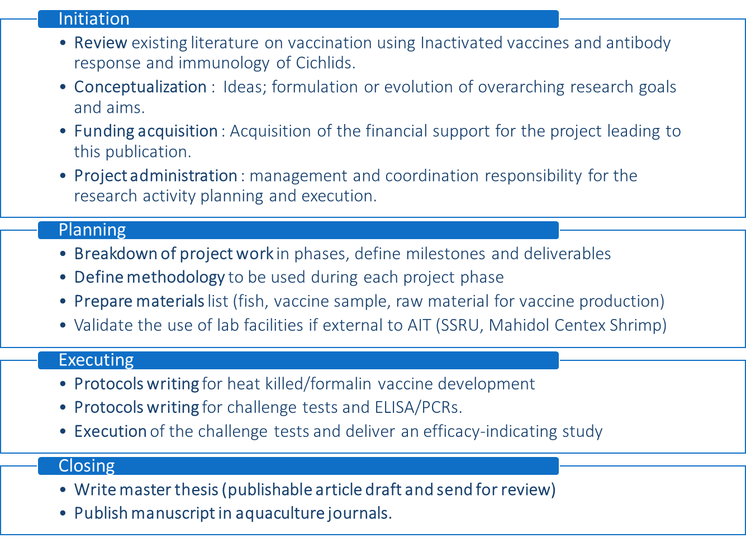

### Study high level roadmap

The Figure 2 shows when I plan to work on the different steps of the project.

Figure 2 *High level roadmap*

# RELEVANT LITERATURE

TO BE DONE LATER This chapter will provide a review of the relevant literature for which my project is based on.

## Relevant literature on *Streptococcus agalactiae* and *Aeromonas veronii* and their infections in Nile tilapia.

## Relevant literature on formalin killed vaccines (FKVs)

## Relevant literature on antibody agglutination titration, ELISA

## Relevant literature on systemic and mucosal fish immunology

## Chapter Summary

# METHODOLOGY AND RAW MATERIAL

TO BE DONE LATER

## Project steps overview

I will describe in the next paragraphs the methodology I will use for each of the steps described in Figure 3. TO BE CONTINUED

## Experimental design and statistical power analysis.

Fish population, n= **400 to 600** individuals

Species = *Oreochromis niloticus*

Age = **juveniles**; Mass = … grams (± SD)=…

All-males sex reversed = **Yes** (genetically females and males)

Origin = Thailand, Asian institute of technology

Strain = **Chitralada 4**

Pathogen free (procedure): Take **6-10** individuals at random, kill them, culture brain and head kidney on TSB for detection of pathogens.

Number of treatments(vaccination) = **4** groups/subsets of approx. **100-150** individuals

**4** ponds/aquariums for **10** days(Acclimatation) + **70** days(post vaccination) = **80** days

Sample not less than **8** fish per group for **blood** and **mucus** swab every week.

**Challenge test:** Separate the fish in 2 sub-groups for Control, Av, Sa. In 3 sub-groups for Sa+Av (bivalent) such as per the following:

**Control** (sham vaccinated) challenged with **Sa** = **33** fish

**Control** (sham vaccinated) challenged with **Av** = **33** fish

**Control** (sham vaccinated) challenged with **PBS** = **33** fish

**Sa monovalent** challenged with **Sa** = **50** fish

**Sa monovalent** challenged with **PBS** = **50** fish

**Av monovalent** challenged with **Av** = **50** fish

**Av monovalent** challenged with **PBS** = **50** fish

**Sa+Av bivalent** challenged with **Sa** = **33** fish

**Sa+Av bivalent** challenged with **Av** = **33** fish

**Sa+Av bivalent** challenged with **PBS** = **33** fish

Statistical power: It is possible to create an artificial population of each group composed of 20 000 sampling with replacement and use the Central limit theorem to deduce the Standard error of the means and infer our vaccine efficiency for all the juveniles Chitralada 4 in the world (main population) with 95% confidence using an approximation of the Standard deviation.

## Methodology for pond preparation and fish stocking

## Methodology for bacterial culture and bacterial preparation

Figure Schema of an antibiogram (general principle)

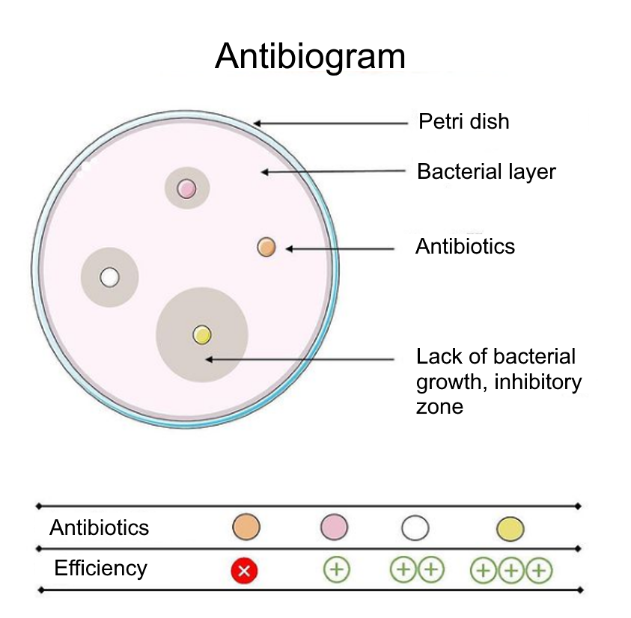

For *Streptococcus agalactiae*

Antibiogram (*Streptococcus agalactiae*):

For *Aeromonas veronii*

Antibiogram (*Aeromonas veronii*):

## Methodology for preparation of formalin killed vaccines (FKVs)

Volume to inject 100μL I.P / fish

## Methodology for vaccine administration in fish and monitoring of fish health during bacterial challenge test.

## Methodology for fish sera and mucus extraction.

## Methodology for ELISA assays for specific IgM, IgT titrations

ELISA is an enzyme-linked immunosorbent assay "for the presence of antibodies, antigens", proteins and glycoproteins in biological samples. This technique is widely used for rapid diagnostic tests such as the diagnosis of HIV infection, pregnancy tests or the detection of food allergens.

The principle of this technique is based on the use of an enzyme conjugated to an antibody which by reacting with a colorless substrate gives a colored reaction product and which is therefore detectable. This is called a chromogenic substrate. Different enzymes are used for ELISA tests including alkaline phosphatase, horseradish peroxidase or beta-galactosidase.

The ELISA assay will give information on the antibody titer of the fish, the IgM and IgT or Immunoglobulins M and the Immunoglobulins T respectively will be targeted in the assay.

## Methodology for RT-PCR

## Methodology for antibody agglutination titration

## Methodology for data curation and result analysis

ANOVA 1 way, + post hoc test tukey with signif not more than 0.05, Rstudio

## List of raw material

## Price of raw material

## Chapter Summary

# EXPERIMENTS AND RESULTS

TO BE DONE LATER This chapter will describe the experiments done.

## Experiment #1

## Experiment #2

….

## Chapter Summary

# CONCLUSION

TO BE DONE LATER

# REFERENCES

# APPENDICES

APPENDIX A  
TITLE

Different materials are presented in the APPENDICES. Label the materials in the order that they are mentioned in the text or section (e.g., “see Appendix A for the questions”). Large or oversized tables or figures that support, but are not important in the text, are included in the appendices in a portrait or landscape orientation. This section is for a single table, figure, image, or illustration.

APPENDIX B  
TITLE

This section is for multiple tables and / or figures. You can also write a short description of this section.

**Table A1 Title**

Add the table here with proper formatting style.

**Table A2 Title**

Add the table here with proper formatting style.

**Figure A1 Title**

Add the figure here with proper formatting style.

**Figure A2**

Add the figure here with proper formatting style.

# VITA

**Quentin Andres**



## Education

**> MSc in Aquaculture and Aquatic Resources Management**

Asian Institute of Technology (AIT) International master program,

English taught, August 2020 to May 2022. - Bangkok, Thailand.

**> BSc in Life Sciences - Major Molecular Biology, Microbiology and Genetics**

BSc in Life Sciences - Major Molecular Biology, Microbiology and Genetics University Cote d'Azur (UCA) - Nice, France

## Conferences & Workshops

**> ARCH-UK Gene-editing Workshop, Applications for Aquaculture**

Latest in vivo and in-vitro techniques. Interactive networking. Policy challenge. Future outlook.

**> AIT-Virtual Aquaculture Internship 2021, Sustainable Aquaculture Systems and Practices**

Sustainable Aquaculture Systems and Practices

**> I-FLOCS 2020 Virtual Aquaculture Workshop**

Innovative Bio-floc Technologies For Sustainable Production of Tilapia and Shrimps

**> Aquaculture in the desert: the example of GCC countries**

(FAO) Celebrating a Quarter of Century of Responsible Fisheries and Aquaculture: Sustainable and resource efficient examples of desert aquaculture from the GCC countries, following the Code of Conduct for Responsible Fisheries (CCRF).

**> 3rd Tuna Webinar Series, Certification and Technology**

INFOFISH Tuna 2020 Virtual Conference and Exhibition

## Trainings & Self-Learning MOOCs

**> Data Analysis for Life Sciences (HarvardX)**

Statistics and R. // Introduction to Linear Models and Matrix Algebra. // Statistical Inference and Modeling for High-throughput Experiments. // High-Dimensional Data Analysis

**> Statistical Inference (Johns Hopkins University)**

by Johns Hopkins University

**> Training on Aquaculture Biosecurity for the Asia-Pacific Region**

Training course on Mariculture Technologies for the Asia-Pacific Region hosted by Belt and Road, Training on Aquaculture Biosecurity, Ministry of Agriculture and Rural Affairs, People's Republic of China and Network of Aquaculture Centers in Asia-Pacific (NACA). December 15th-18th Qingdao, China

**> Training Manual on Mariculture Technologies for the Asia-Pacific Region**

Training course on Mariculture Technologies & Integrated Multitrophic Aquaculture (IMTA) for the Asia-Pacific Region hosted by Belt and Road, Training base for mariculture technologies, Ministry of Agriculture and Rural Affairs, People's Republic of China and Network of Aquaculture Centers in Asia-Pacific (NACA). September 21st-25th Qingdao, China